

Software Testing Hackathon Level-2

**Team name:** APHRODITE

College name: M.A.M College of Engineering

**Team Member 1:** Prathish Deivendiran

Email: dineshprathish@gamil.com

Naan Mudhalvan ID: au812621243014

Phone No: 9080428386

**Team Member 2:** Rakshana M

Email: rakshanamurugeasan0411@gmail.com

Naan Mudhalavan ID: au812621243035

Phone No: 6384146276

**Team Member 3:** Naveen M

Email: Naveen271103@gmail.com

Naan Mudhalavan id: au812621205034

Phone No: 7810089033

**Automation Software Testing Description**

In this automation testing we performed 15 test cases . Some test cases are performed with data and some are without data .

Things which we are installed to perform the software testing

Jdk version-11 , eclipse , selenium and chrome web driver

By performing this Automation testing we can improve testing efficiency ,accuracy, and speed by automating repetitive and time consuming manual testing.

Since we performed 15 test cases and in particular one test case we provide a sample data in phone number box as 8000000000 and remaining data’s are original data such as Name : prathish and Email: [dineshprathish@gmail.com](mailto:dineshprathish@gmail.com) this Test case ID:TC001. If we provide a original phone number the test case will execute and ask for the OTP of the particular number therefore we give the invalid number to ensure whether the page is running properly .

**Test Case Sheet**

|  |  |  |  |  |
| --- | --- | --- | --- | --- |
| **TEST CASE ID** | **TEST CASE DESCRIPTION** | **TEST STEPS** | **TEST DATA** | **TEST STATUS** |
| **TC001** | **User registration:**  Verify that users can successfully register for an account on the AJIO website. | 1. Navigate to the AJIO website. 2. Click on the “Sign Up” or “Register” button. 3. Fill in the required information( name , email , password , etc ) 4. Submit the registration form. 5. Verify that a confirmation message is displayed and the user is redirected to the homepage. | **Name:** Prathish  **Email:** [dineshprathish@gmail.com](mailto:dineshprathish@gmail.com)  **Number:**  8000000000 | **PASS** |
| **TC002** | **Login Functionality:**  Ensure that registered users can log in to their accounts. | 1. Navigate to the AJIO website. 2. Click on the “Login” or “Sign In” button. 3. Enter valid login credentials(email and password). 4. Click on the ”Login “ button. 5. Verify that the user is redirected to their account dashboard. | _____________ | **PASS** |
| **TC003** | **Search Functionality:**  Validate the search functionality by ensuring users can find products using keywords. | 1. Navigate to the AJIO website. 2. Enter a search query in the search bar(e.g., ”shoes”). 3. Press Enter or click on the search icon. 4. Verify that relevant products matching the search query are displayed. 5. Ensure that pagination or infinite scroll functionality works correctly if there are multiple pages of search results. | **Search:**  Men shirt | **PASS** |
| **TC004** | **Add to Cart:**  Test the ability to add products to the shopping cart. | 1. Navigate to a product page on the AJIO website. 2. Select the desired product variant (Size, color ,etc). 3. Click on the “Add to Cart” button. 4. Verify that a confirmation message is displayed and the product is added to the cart. 5. Optionally navigate to the cart page to confirm the product is listed. | **Product size:**  M | **PASS** |
| **TC005** | **Checkout Process:**  Ensure a smooth checkout process for users. | 1. Add one or more products to the shopping cart. 2. Navigate to the cart page. 3. Click on the “Proceed to Checkout” button. 4. Enter shipping and billing information (if applicable). 5. Choose a payment method and complete the transaction. 6. Verify that the order is placed successfully, and the user receives an order confirmation | ______________ | **PASS** |
| **TC006** | **Product 2 Details Page:**  Validate that product details are accurately displayed on the product page. | 1. Navigate to a product page on the AJIO website. 2. Verify that product images, descriptions pricing and other relevant details are present. 3. Check that product variants(size, color, etc) are displayed correctly, if applicable. 4. Ensure that product reviews and rating (if available) are shown accurately. 5. Verify that the “Add to cart” button is visible and functional. | _____________ | **PASS** |
| **TC007** | **Sorting and Filtering**:  Test the functionality to sort and filter search results. | 1. Perform a search or navigate to a product category on the AJIO website. 2. Apply different sorting options (e.g., price low to high, popularity). 3. Verify that search results are sorted accordingly. 4. Apply various filters (e.g., brand, size, price range). 5. Ensure that filtered results match the selected criteria. | **Price range:**  1000 Rs-1500Rs | **PASS** |
| **TC008** | **Selecting the product from Ajioluxe:**  Verifying the product is  Choose from the image in ajoluxe webpage. | 1. Choose the watch image in the ajioluxe. 2. Verify that watch are exact image of the web page advertisement. 3. Verify the detail of the watch. | ____________ | **PASS** |
| **TC009** | **Adding the product to the cart from Ajioluxe :**  After the test case of the **TC008** then adding the same product to the cart | 1. After choosing the product which was done in the testcase **TC008.** 2. Then add the product to the cart here we use branded watch . | ____________ | **PASS** |
| **TC010** | **Guest Checkout:**  Ensure that guest users can complete purchases without registering for an account. | 1. Proceed to checkout as a guest user(without logging in). 2. Enter shipping and billing information. 3. Choose a payment method and complete the transaction. 4. Verify that the order is placed successfully without requiring account registration. 5. Optionally, check if the guest user receives an order confirmation email. | ____________ | **PASS** |
| **TC011** | **Promotional Discounts:**  Test the application of promotional discounts and coupons during checkout. | 1. Add products to the shopping cart. 2. Apply a valid promotional code or discount coupon. 3. Verify that the discount is applied correctly to the order total. 4. Ensure that the discount code is validated for eligibility criteria. 5. Complete the checkout process and confirm the discounted price on the order summary. | **Coupon code:**  NEW1000 | **PASS** |
| **TC012** | **Ajioluxe:**  Ensure that the page is navigating to the ajioluxe from the home page of ajio | 1. Search for the product from the Ajioluxepage. 2. Select the product watch from the image shown 3. Verify that the current product detail is displayed properly. | ______________ | **PASS** |
| **TC013** | **Mobile Responsiveness:**  Ensure that the AJIO website is properly optimized for mobile devices | 1. Access the AJIO website using various mobile devices (smartphones ,tablets). 2. Verify that the layout and functionality remain consistent across different screen sizes. 3. Test navigation buttons and form fields for usability on mobile devices. 4. Ensure that images and text are appropriately resized for mobile viewing. 5. Check for any mobile-specific bugs or display issues. | ______________ | **PASS** |
| **TC014** | **Customer Support:**  Validate the customer support channels available on the AJIO website. | 1. Locate and access the customer support section of the AJIO website. 2. Test the live chat functionality (if available) by initiating a chat session. 3. Check for the availability of contact information such as phone numbers and email addresses. 4. Send a test email inquiry to the provided support email address. 5. Verify that responses are received in a timely manner and address the inquiry effectively | ______________ | **PASS** |
| **TC015** | **Homepage Navigation:**  Verify that users can successfully navigate to the homepage of the AJIO website. | 1. Open a web browser and navigate to the AJIO websit([WWW.ajio.com](http://WWW.ajio.com)). 2. Verify that the homepage loads correctly, displaying the main banner, product categories, and featured items. 3. Check that the navigation menu(e.g., shop by category, brands) is visible and functional. 4. Click on the AJIO logo or the “Home’ button (if available) to ensure it redirects to the homepages. | **Product Category**:    1)Men Cloths  2)Watch | **PASS** |

**Source Code Of Automation Software Testing**

package testng;

import org.testng.annotations.Test;

import org.testng.annotations.AfterTest;

import org.testng.annotations.BeforeMethod;

import java.util.concurrent.TimeUnit;

import org.openqa.selenium.By;

import org.openqa.selenium.Keys;

import org.openqa.selenium.WebDriver;

import org.openqa.selenium.chrome.ChromeDriver;

public class AjioTestNG {

WebDriver ajio;

@SuppressWarnings("deprecation")

@BeforeMethod

public void startup() {

System.getProperty("webdriver","C:\\Users\\Admin\\Downloads\\chromedriver-win64\\chromedriver-win64\\chromedriver.exe");

ajio = new ChromeDriver();

ajio.manage().deleteAllCookies();

ajio.manage().timeouts().pageLoadTimeout(10,TimeUnit.SECONDS);

ajio.manage().timeouts().implicitlyWait(10,TimeUnit.SECONDS);

ajio.get("https://www.ajio.com/");

// Mobile Responsiveness:

ajio.manage().window().maximize();

}

@Test

public void ajio() throws InterruptedException {

//Customer Care:

Thread.sleep(3000);

ajio.findElement(By.xpath("//*[@id=\"appContainer\"]/div[1]/div/header/div[1]/ul/li[2]/a")).click();

Thread.sleep(3000);

ajio.findElement(By.xpath("//*[@id=\"appContainer\"]/div[1]/div/header/div[2]/a/img")).click();

//Ajioluxe:

Thread.sleep(3000);

ajio.findElement(By.xpath("//*[@id=\"appContainer\"]/div[1]/div/header/div[1]/ul/li[3]/a")).click();

//Selecting Branded Premium Watch:

Thread.sleep(2000);

ajio.findElement(By.xpath("//*[@id=\"main-content\"]/div/div[22]/div/div/div/div/div/div/div/div/div[1]/div/div/a[2]")).click();

//Selecting The Product:

Thread.sleep(2000);

ajio.get("https://luxe.ajio.com/maserati-analogue-watch-with-chain-strap/p/463719191_multi");

//Product Details 1:

Thread.sleep(2000);

ajio.findElement(By.xpath("//*[@id=\"appContainer\"]/div[2]/div/div/div[2]/div/div[3]/div/section/h2[2]/ul/li[10]/div")).click();

//Add To Cart 1:

Thread.sleep(2000);

ajio.findElement(By.xpath("//*[@id=\"appContainer\"]/div[2]/div/div/div[2]/div/div[3]/div/div[7]/div[1]/div[1]/div")).click();

//Back To Ajio:

Thread.sleep(5000);

ajio.findElement(By.xpath("//*[@id=\"appContainer\"]/div[1]/div[1]/header/div[1]/ul/li[3]")).click();

//search Functionality:

Thread.sleep(2000);

ajio.findElement(By.xpath("//*[@id=\"appContainer\"]/div[1]/div/header/div[3]/div[2]/form/div/div/input")).sendKeys("Men Shirt"+Keys.ENTER);

//Sorting and Filtering2:

Thread.sleep(2000);

ajio.findElement(By.xpath("//*[@id=\"facets\"]/div[2]/ul/li[3]/div/div/div/span[2]")).click();

Thread.sleep(2000);

ajio.findElement(By.xpath("//*[@id=\"facets\"]/div[2]/ul/li[3]/div/div/div[2]/ul/li[3]/div/div/label")).click();

Thread.sleep(2000);

ajio.findElement(By.xpath("//*[@id=\"facets\"]/div[2]/ul/li[8]/div/div/div[1]/span[2]")).click();

Thread.sleep(2000);

ajio.findElement(By.xpath("//*[@id=\"facets\"]/div[2]/ul/li[8]/div/div/div[2]/ul/li[3]/div/div/label")).click();

//Product Selection:

Thread.sleep(2000);

ajio.get("https://www.ajio.com/dnmx-men-slim-fit-shirt-with-flap-pockets/p/443016509_khaki");

//Product Details 2:

Thread.sleep(2000);

ajio.findElement(By.xpath("//*[@id=\"appContainer\"]/div[2]/div/div/div[2]/div/div[3]/div/section/h2[2]/ul/li[7]/div")).click();

//Add To Cart 2:

Thread.sleep(2000);

ajio.findElement(By.xpath("//*[@id=\"appContainer\"]/div[2]/div/div/div[2]/div/div[3]/div/div[7]/div[2]/div/div/div[3]/div")).click();

Thread.sleep(2000);

ajio.findElement(By.xpath("//*[@id=\"appContainer\"]/div[2]/div/div/div[2]/div/div[3]/div/div[10]/div[1]/div[1]/div")).click();

//Home page navigation:

Thread.sleep(10000);

ajio.findElement(By.xpath("//*[@id=\"appContainer\"]/div[1]/div/header/div[2]/a/img")).click();

//Verify Cart

Thread.sleep(2000);

ajio.findElement(By.xpath("//*[@id=\"appContainer\"]/div[1]/div/header/div[3]/div[2]/div[2]/a/div")).click();

//Promotional Discount:

Thread.sleep(3000);

ajio.findElement(By.xpath("//*[@id=\"couponCodeInput\"]")).sendKeys("NEW1000"+Keys.ENTER);

Thread.sleep(3000);

ajio.findElement(By.xpath("//*[@id=\"dCartWrapper\"]/div[2]/div[2]/div[1]/div[3]/div[2]/div[2]")).click();

Thread.sleep(3000);

ajio.findElement(By.xpath("//*[@id=\"saving-popup-btn\"]")).click();

Thread.sleep(3000);

ajio.findElement(By.xpath("//*[@id=\"dCartWrapper\"]/div[2]/div[2]/div[1]/div[4]/div[2]/div[2]")).click();

Thread.sleep(3000);

ajio.findElement(By.xpath("//*[@id=\"saving-popup-btn\"]")).click();

Thread.sleep(3000);

ajio.findElement(By.xpath("//*[@id=\"dCartWrapper\"]/div[2]/div[2]/div[2]/div[3]/div/div[2]/div/button")).click();

//Login Functionality:

Thread.sleep(3000);

ajio.findElement(By.xpath("//*[@id=\"loginAjio\"]")).click();

Thread.sleep(2000);

ajio.findElement(By.xpath("//*[@id=\"login-modal\"]/div/div/div[2]/div/form/div[2]/div[1]/label/input")).sendKeys("8000000000"+Keys.ENTER);

Thread.sleep(2000);

ajio.findElement(By.xpath("//*[@id=\"login-modal\"]/div/div/div[2]/div[2]/form/div[3]/label[2]")).click();

Thread.sleep(2000);

ajio.findElement(By.xpath("//*[@id=\"login-modal\"]/div/div/div[2]/div[2]/form/div[5]/input")).sendKeys("Prathish"+Keys.ENTER);

Thread.sleep(2000);

ajio.findElement(By.xpath("//*[@id=\"login-modal\"]/div/div/div[2]/div[2]/form/div[7]/input")).sendKeys("dineshprathish@gmail.com"+Keys.ENTER);

Thread.sleep(2000);

ajio.findElement(By.xpath("//*[@id=\"login-modal\"]/div/div/div[2]/div[2]/form/div[10]/label/span")).click();

Thread.sleep(2000);

}

@AfterTest

public void quit() {

ajio.quit();

}

}

**TestNG Screenshot Of Chronological View**

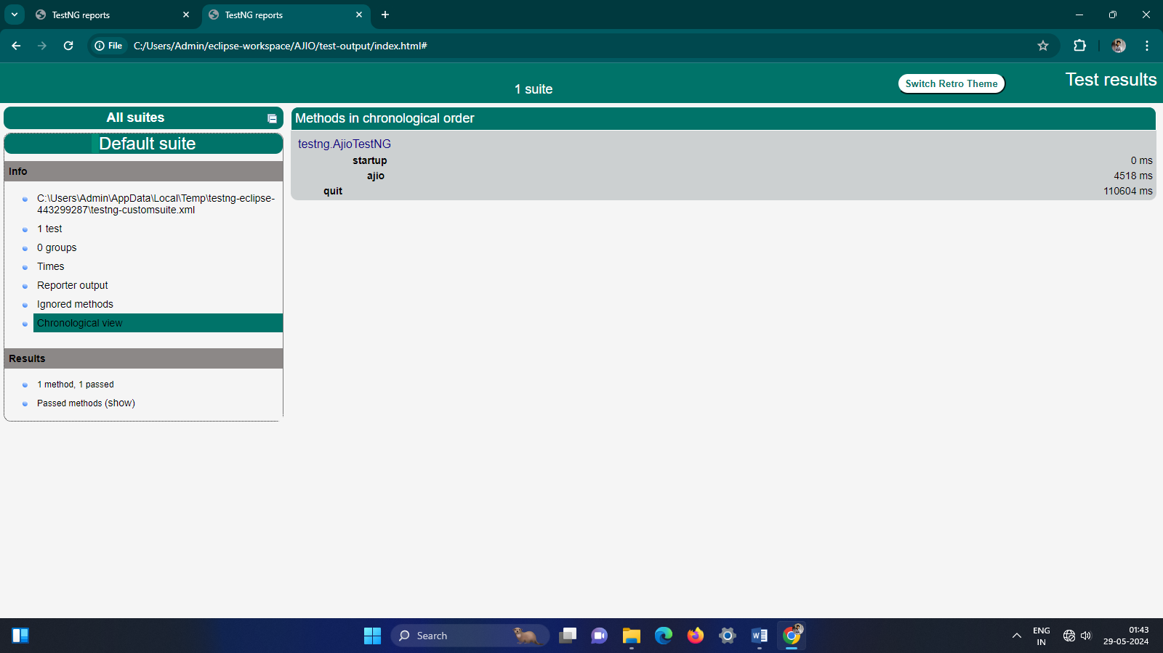

**Automation Software Testing Output**

